Submitted by: MUHAMMAD BILAL HAMZA

LINK: https://drive.google.com/file/d/1ssa4WMUWHyhwmPt6O81-xBg6FfBlFRTF/view?usp=drive_link

Objective(s):
The goal of this project is to apply the systems and network administration concepts and skills acquired during lab sessions in a practical scenario.

Project Requirements:

Device | Interface | IP Address | Subnet Mask | Default Gateway
CENTER | S0/2/0 | 192.168.10.2 | 255.255.255.0 | N/A
CENTER | S0/2/1 | 192.168.100.2 | 255.255.255.0 | N/A
CENTER | S0/3/0 | 192.168.4.3 | 255.255.255.0 | N/A
CENTER | S0/3/1 | 192.168.5.3 | 255.255.255.0 | N/A
CENTER | S1/0 | 192.168.50.2 | 255.255.255.0 | N/A
CENTER | S1/1 | 192.168.60.2 | 255.255.255.0 | N/A
CENTER | S1/2 | 192.168.2.3 | 255.255.255.0 | N/A
CENTER | S1/3 | 192.168.3.3 | 255.255.255.0 | N/A
L1  L2 | G0/0 | 192.168.9.1 | 255.255.255.0 | N/A
L1  L2 | G0/1 | 192.168.10.1 | 255.255.255.0 | N/A
L1  L2 | S0/0/0 | 192.168.30.2 | 255.255.255.0 | N/A
L1  L2 | S0/0/1 | 192.168.5.2 | 255.255.255.0 | N/A
L1  L2 | G0/0 | 192.168.7.1 | 255.255.255.0 | N/A
L1  L2 | G0/1 | 192.168.8.1 | 255.255.255.0 | N/A
L1  L2 | S0/0/0 | 192.168.30.1 | 255.255.255.0 | N/A
L1  L2 | S0/0/1 | 192.168.4.2 | 255.255.255.0 | N/A
SASAS  L  L1.1  L | NIC | 192.168.9.2 | 255.255.255.0 | 192.168.9.1
L1.2 | NIC | 192.168.9.3 | 255.255.255.0 | 192.168.9.1
L1L L1.3 | NIC | 192.168.9.4 | 255.255.255.0 | 192.168.9.1
DHCP PUNJAB |  | 192.168.10.2 | 255.255.255.0 | 192.168.10.1
DNS SERVER  PUNJAB | NIC | 192.168.10.2 | 255.255.255.0 | 192.168.10.1
L2 1.1 | NIC | 192.168.8.2 | 255.255.255.0 | 192.168.8.1
L2 1.2 | NIC | 192.168.8.3 | 255.255.255.0 | 192.168.8.1
FTP SERVER  PUNJAB | NIC | 192.168.8.4 | 255.255.255.0 | 192.168.8.1
L2 2.1 | NIC | 192.168.7.2 | 255.255.255.0 | 192.168.7.1
SL2 2.2 | NIC | 192.168.7.3 | 255.255.255.0 | 192.168.7.1
L2 2.3 | NIC | 192.168.7.4 | 255.255.255.0 | 192.168.7.1
AXzxxxXXZ  S2 | G/0/0 | 192.168.18.1 | 255.255.255.0 | N/A
AXzxxxXXZ  S2 | G/0/1 | 192.168.18.1 | 255.255.255.0 | N/A
AXzxxxXXZ  S2 | S0/0/0 | 192.168.50.2 | 255.255.255.0 | N/A
AXzxxxXXZ  S2 | S0/0/1 | 192.168.3.2 | 255.255.255.0 | N/A
DNS SERVER  SINDH | NIC | 192.168.19.4 | 255.255.255.0 | 192.168.19.1
S2 2.1 | NIC | 192.168.18.2 | 255.255.255.0 | 192.168.18.1
S2 2.2 | NIC | 192.168.18.3 | 255.255.255.0 | 192.168.18.1
S2 2.3 | NIC | 192.168.18.4 | 255.255.255.0 | 192.168.18.1
DHCP SERVER  SINDH | NIC | 192.168.18.5 | 255.255.255.0 | 192.168.18.1
B2 | G/0/0 | 192.168.14.1 | 255.255.255.0 | N/A
B2 | G/0/1 | 192.168.15.1 | 255.255.255.0 | N/A
B2 | S0/0/0 | 192.168.40.2 | 255.255.255.0 | N/A
B2 | S/0/0/1 | 192.168.60.1 | 255.255.255.0 | N/A
B1 1.1 | NIC | 192.168.13.2 | 255.255.255.0 | 192.168.13.1
B1 1.2 | NIC | 192.168.13.3 | 255.255.255.0 | 192.168.13.1
FTP BAL | NIC | 192.168.13.4 | 255.255.255.0 | 192.168.13.1
B1 2.1 | NIC | 192.168.12.2 | 255.255.255.0 | 192.168.12.1
B1 2.2 | NIC | 192.168.12.3 | 255.255.255.0 | 192.168.12.1
B1 2.3 | NIC | 192.168.12.4 | 255.255.255.0 | 192.168.12.1
B2 2.1 | NIC | 192.168.14.4 | 255.255.255.0 | 192.168.14.1
DHCP-BAL | NIC | 192.168.14.3 | 255.255.255.0 | 192.168.14.1
B2 2.2 | NIC | 192.168.14.2 | 255.255.255.0 | 192.168.14.1
B2 2.3 | NIC | 192.168.14.5 | 255.255.255.0 | 192.168.14.1
B2 2.4 | NIC | 192.168.14.6 | 255.255.255.0 | 192.168.14.1
DNS SERVER  BAL | NIC | 192.168.15.2 | 255.255.255.0 | 192.168.15.1

You are tasked with designing, installing, and configuring a network infrastructure for an organization of your choice using Cisco Packet Tracer. The network must meet the following specifications:

- The organization should have a head office and at least two branch offices.
HEAD OFFICE IS PUNJAB
BRANCH 1 IS BALOUCHISTAN
BRANCH 2 IS SINDH
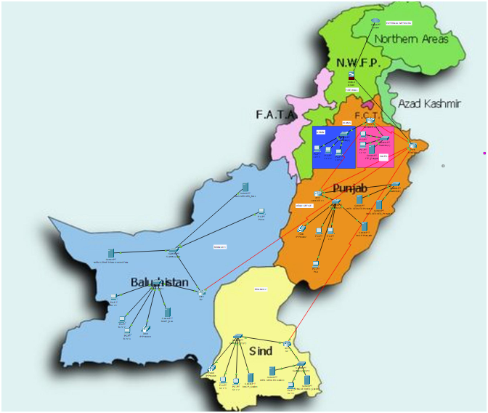
- Establish WAN connectivity between the offices using routers.

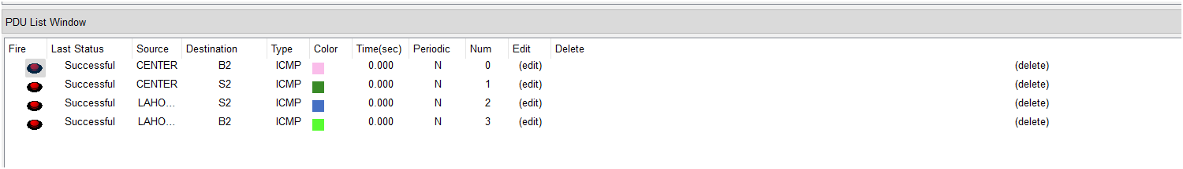
- Configure at least two VLANs at one of the office locations to segment the internal network.
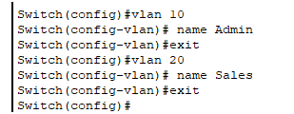
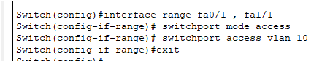
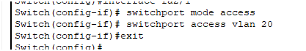
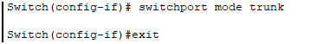
- Set up and configure VoIP (Voice over IP) communication between all offices.
On CENTER router
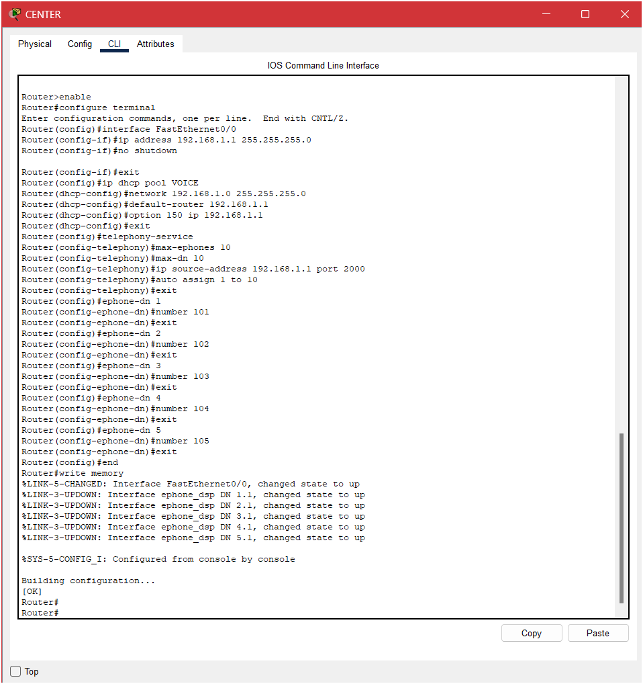

For branches and head offices switches
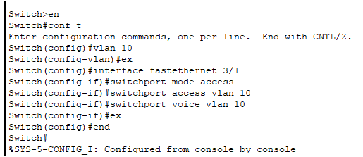
On each branch router :
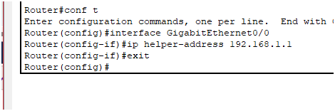

- Deploy and configure a DNS server for name resolution.
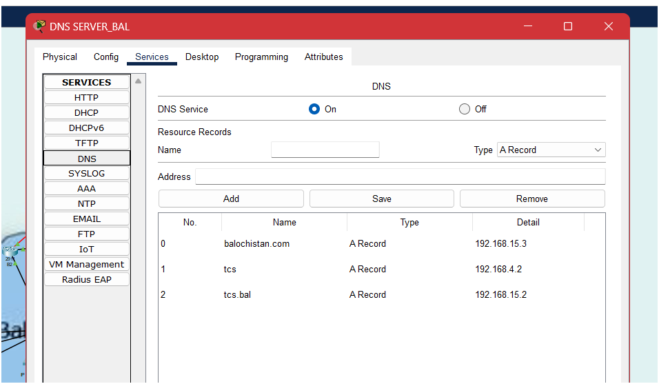
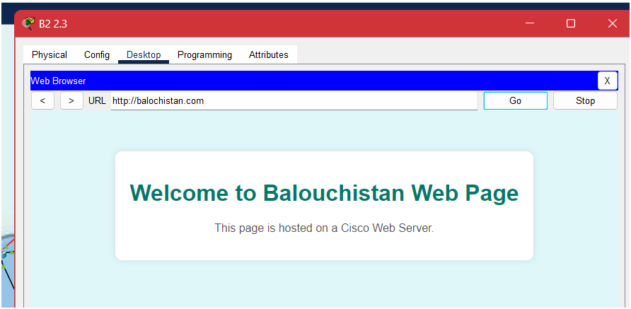
DNS HAS BEEN DONE IN THE NETWORK
- Use DHCP to automatically assign IP addresses across the network.
Before assigning DHCP
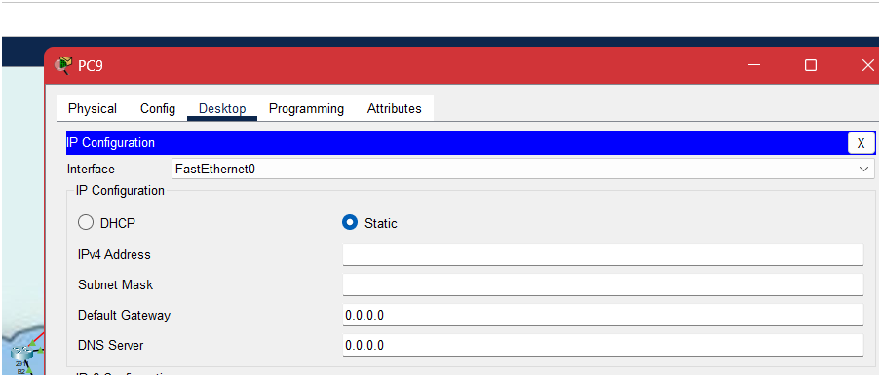
After assigning DHCP
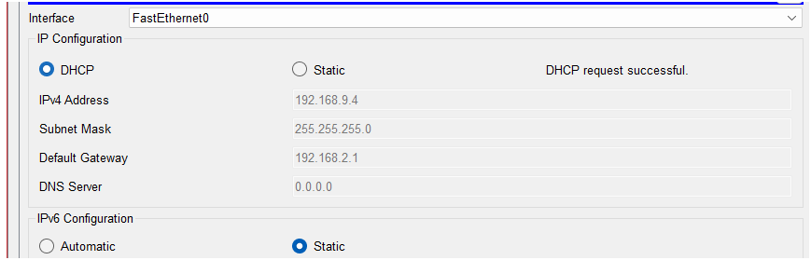

DHCP IS ALSO BUILT ACROSS THE NETWORK

- Implement NAT (Network Address Translation) to enable internet access for internal hosts.
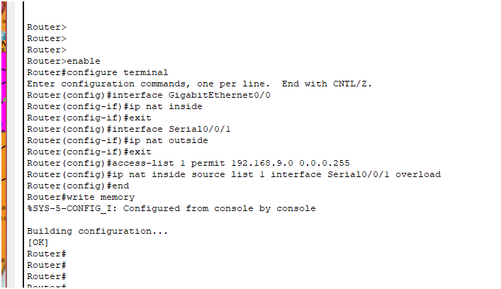
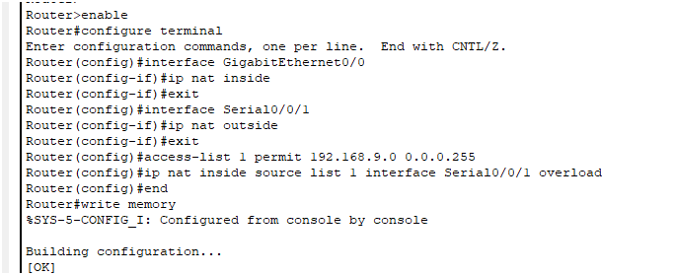

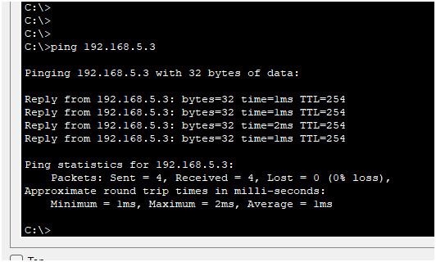

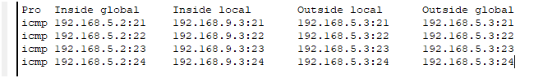

- Install and configure a web server within the network.
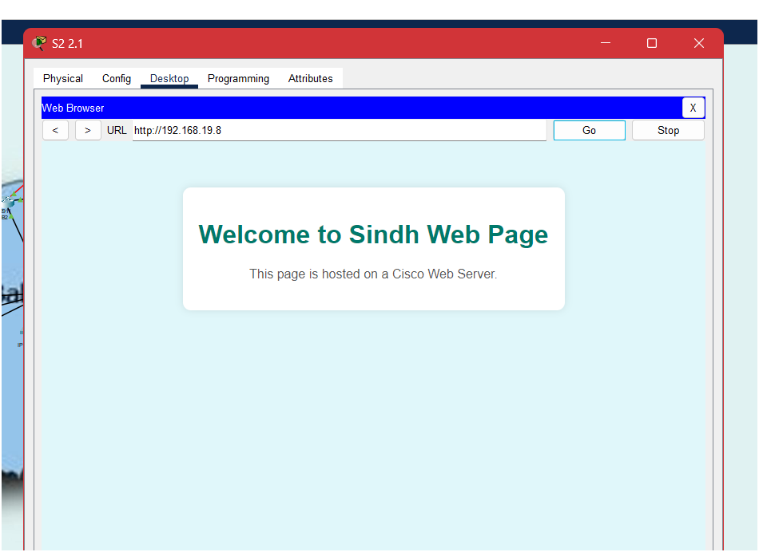
For headoffice , branches all web servers have been separately allocated

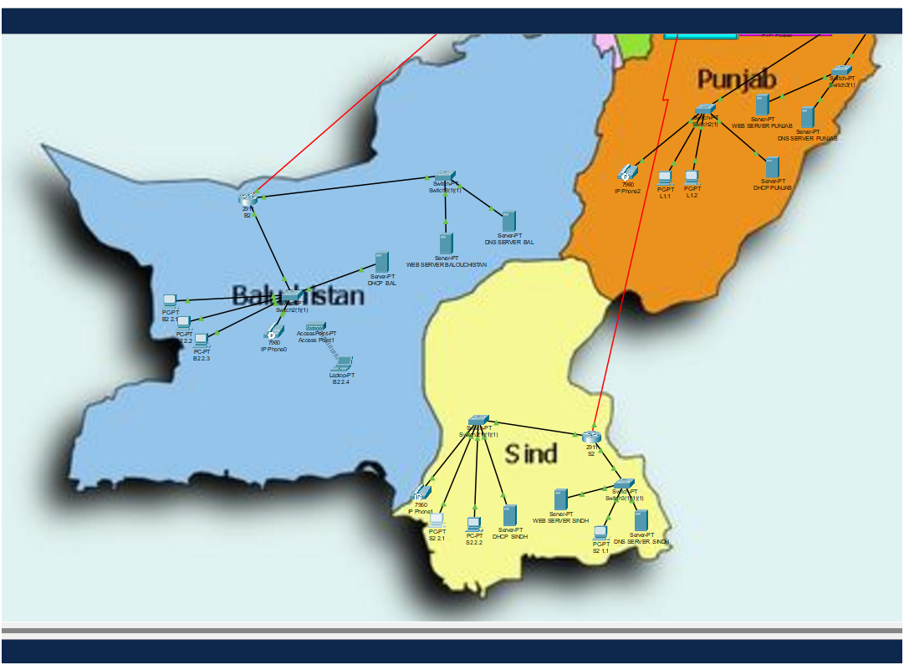
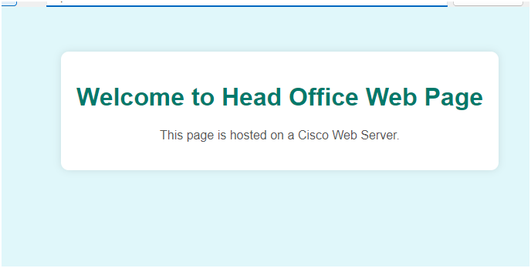
- Apply Access Control Lists (ACLs) to regulate and secure traffic flow between the head office and the branch offices.
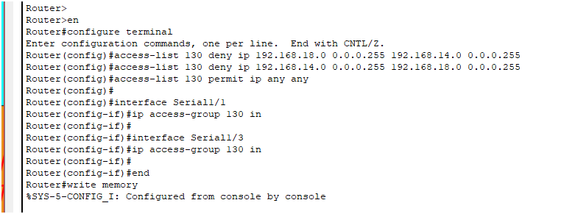

ACL IS ENABLED BETWEEN HALF OF SINDH AND BALOUCHISTAN, you can see picture to
Help you understand
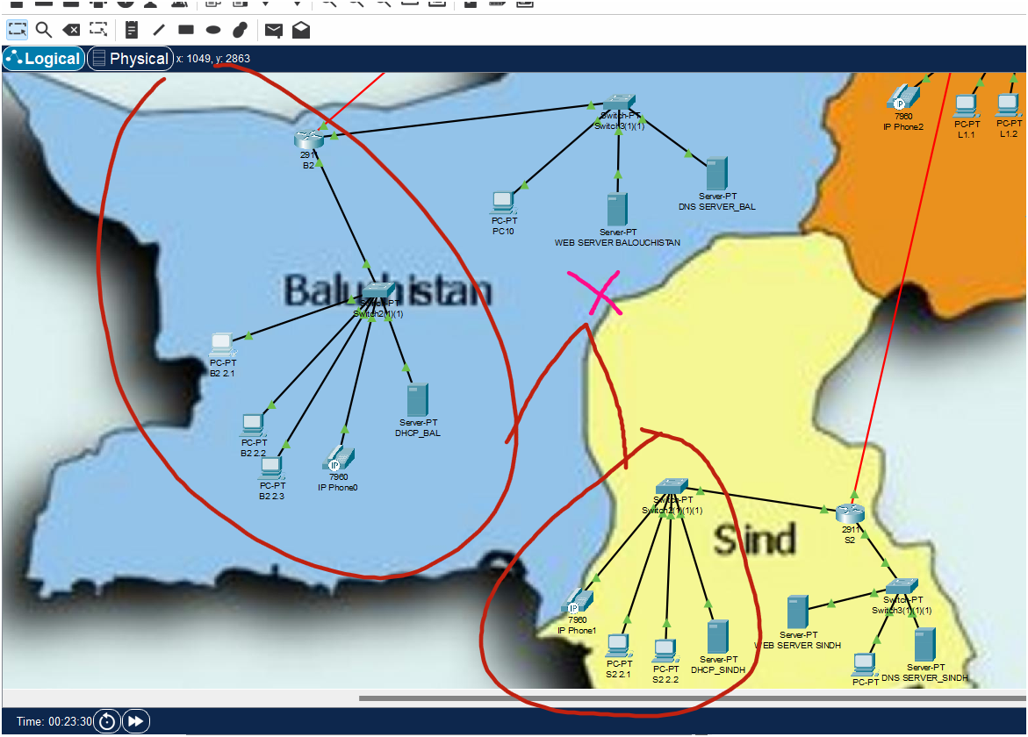
- Set up and configure a Cisco firewall to safeguard the network from external threats.
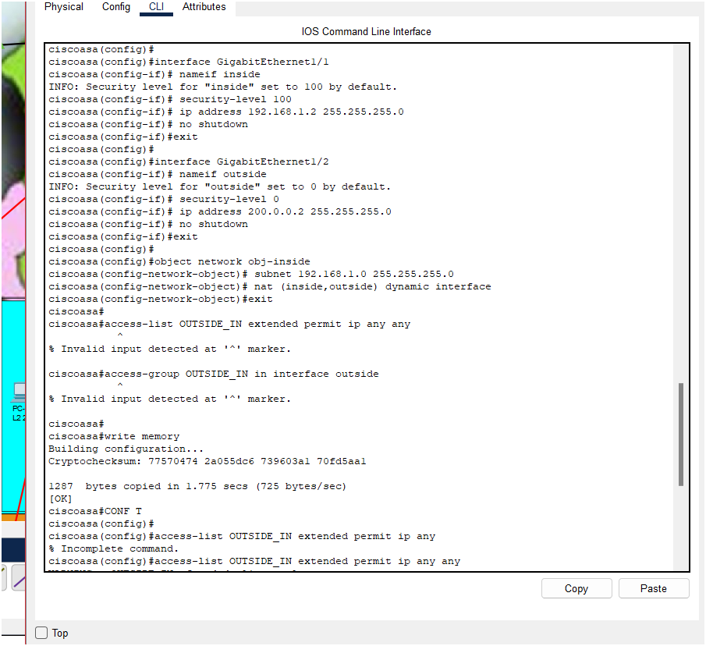

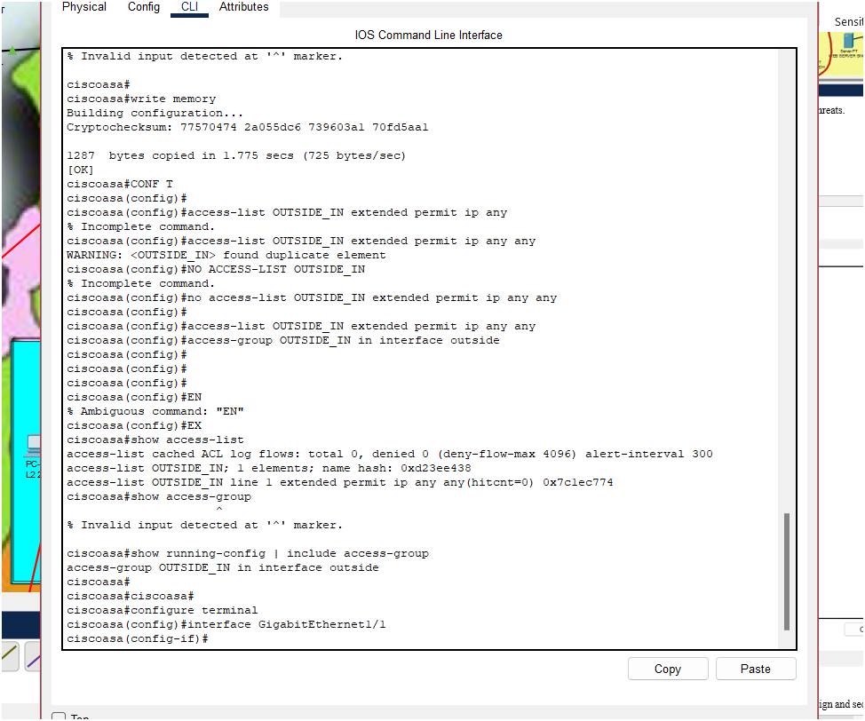

This project is intended to reinforce your understanding of enterprise-level network design and security through hands-on implementation.

Done | Requirement | Status
Yes | The organization should have a head office and at least two branch offices | Complete
Yes | Establish WAN connectivity between the offices using routers | Complete
Yes | Configure at least two VLANs at one of the office locations to segment the internal network | Complete
Yes | Set up and configure VoIP (Voice over IP) communication between all offices | Complete
Yes | Deploy and configure a DNS server for name resolution | Complete
Yes | Use DHCP to automatically assign IP addresses across the network | Complete
Yes | Implement NAT (Network Address Translation) to enable internet access for internal hosts | Complete
Yes | Install and configure a web server within the network | Complete
Yes | Apply Access Control Lists (ACLs) to regulate and secure traffic flow between the head office and the branch offices | Complete
Yes | Set up and configure a Cisco firewall to safeguard the network from external threats | Complete

Project Assessment Rubric – System and Network Administration
Conformance
Level
Conformance Legend |  |  |  |  |  | Excellent | Good | Fair | Poor | Extremely  Poor
Conformance Level %age |  |  |  |  |  | (80-100)% | (60-80)% | (40-60%) | (20-40)% | (0-20)%
Rating |  |  |  |  |  | 4.5 – 5.0 | 3.5 – 4.0 | 2.5 – 3.0 | 1.5 – 2.0 | 0.0 – 1.0
Sr.  No. | Criteria |  | Description | Skill | Marks Weight age
1. |  | Design | This portion reflects the design portion of the project including diagrams timelines and outlines,. | Logical and  physical  Topologies | 6 | Design is complex, includes flow chart, and timeline. Goals and written  description of  project are present. Schematics exist and are readable. Design has been updated to  represent final  project, and all versions are  included. | Design is mostly complete, some updates, but not current. | Basic design, Not updated. | Little or no design present. | No design
2. |  | Hardware | The hardware part of the project includes  building the network. | Network Hardware knowledge | 4 | Network hardware correctly implemented all components communicate; network is consistent with design | Project is built, all hardware components are implemented network communicates but numerous problems are present does not match design. | All required network hardware has been implemented, however not working. | Only one or two hardware components have been implemented, network does not communicate. | No Hardware used.

3. | Software | This is the software  component of this  project. Students  will install server  and client software  and make  appropriate network connections | Knowledge of  NOS, and  Simulator | 6 | All software is  installed and  working  correctly, all  networking  tests are  passed. | Most software  is installed,  and installed  components  are working  correctly, most networking  test are  passed. | All software is  installed  however not  correctly  working. | Not all software is installed on all  machines. | No  software  installed  at all.
4. | Testing and Documentation | Students run appropriate network tests and  document all problems encountered and  corrections made. | Problem Solving | 4 | Great  All tests were  completed  successfully and full documentation exists on any  problems  encountered, and solutions applied. | All test were  completed,  successfully  limited  documentation on problems  and  corrections. | Some testing was done, problems documented but corrections not  implemented or documented. | Testing was not done appropriately. | No  testing  done at  all.

